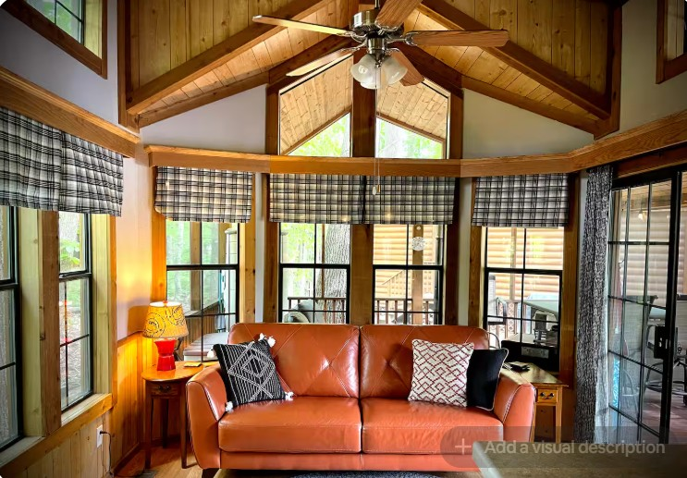
B-5
This Cabin Built by Athens Park Homes offers a one bedroom with two sleeping lofts. The interior has a mixture of tape & texture walls with rough sewn cedar paneling. The kitchen features a tile backsplash and includes a 30” black gas range, over-the-range microwave with hood and white 18 cubic foot refrigerator. The cabin includes a queen size bed, sofa, table with two chairs and a TV. The huge wraparound screened porch area is approximately 580 sq. ft. The cabin is located in the desirable “B” section of Lakeside Cabins Resort which is right by the playground. Gorgeous Ravine view!
ATHENS

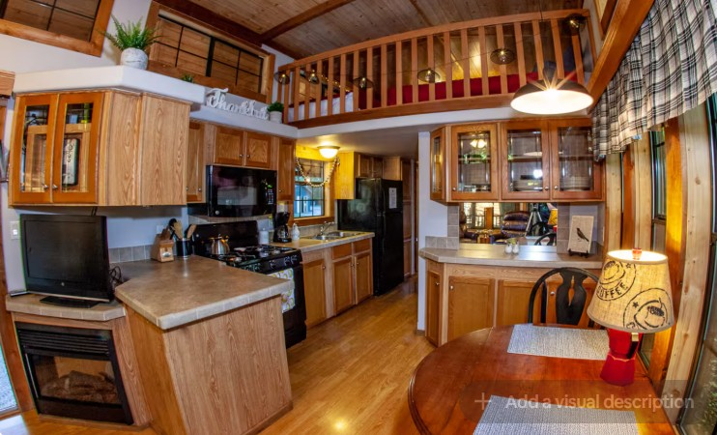
Cabin For Sale
$209,900
